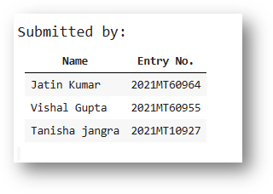

**MTL 782 Assignment 2 Report**

### **Q1(a),(b)**

1). The MNITST Dataset looks like this:

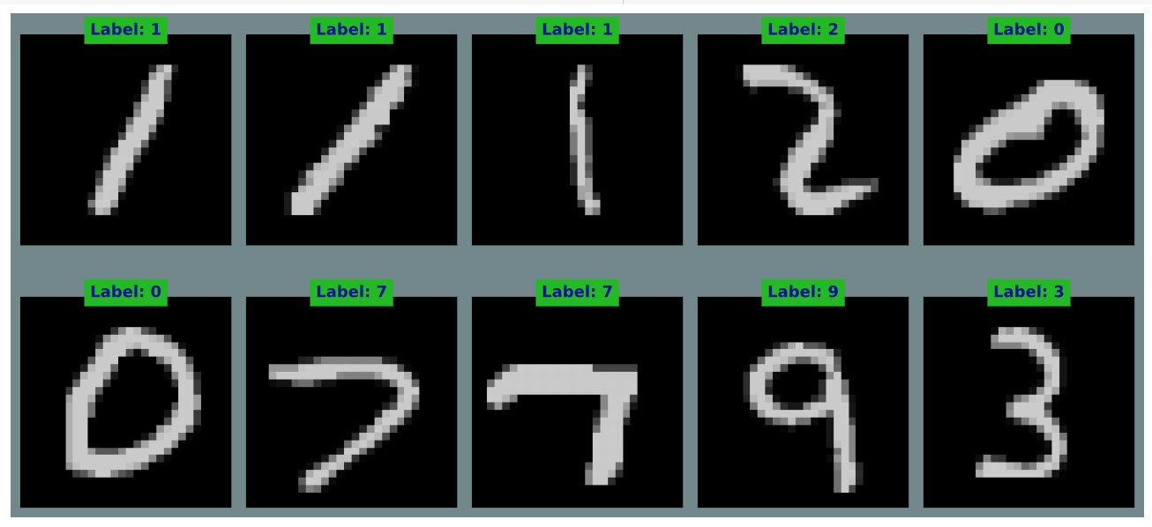

2). Evaluation of dataset using Multinomial Naive Bayes:

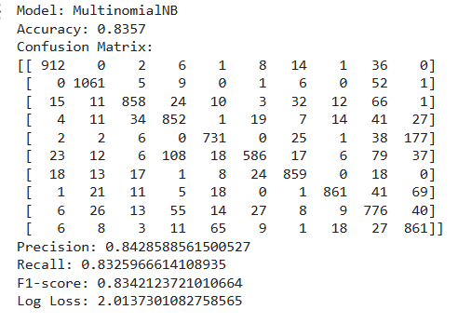

3). Evaluation of dataset using kNeighbours Classifier:

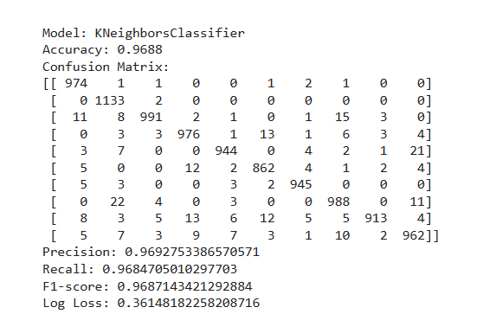  
4). Evaluation of dataset using multi-layer Neural Nets:

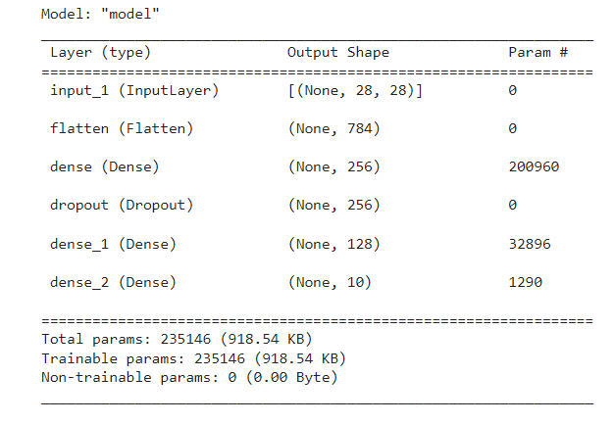

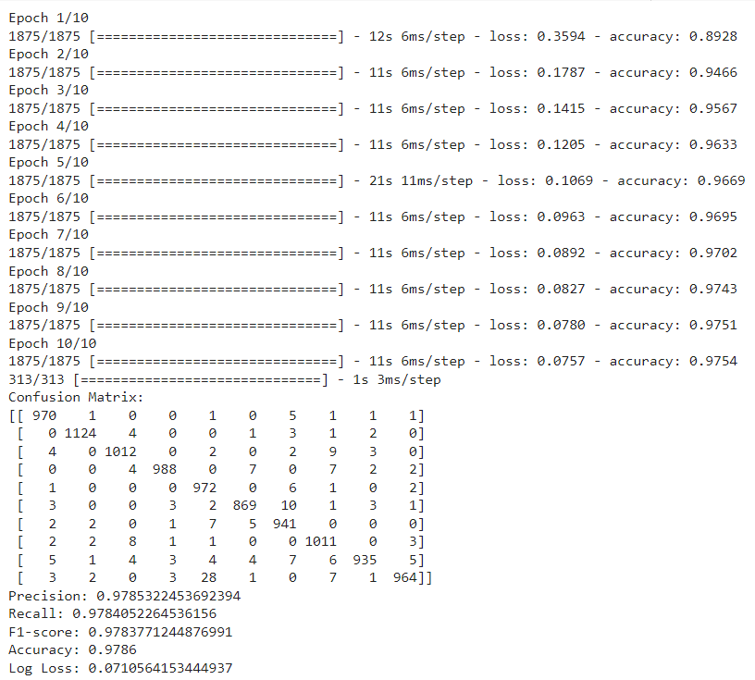

5). (a) Decision Tree Accuracy Vs Depth

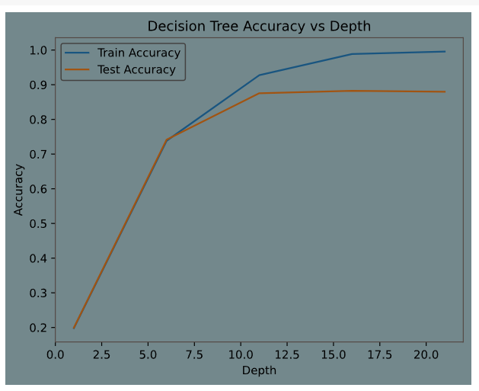

5).(b) Analysis using Decision Tree

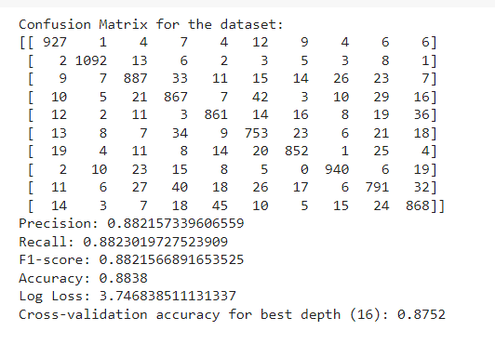

6).(a)Analysis using Random forest Classifier

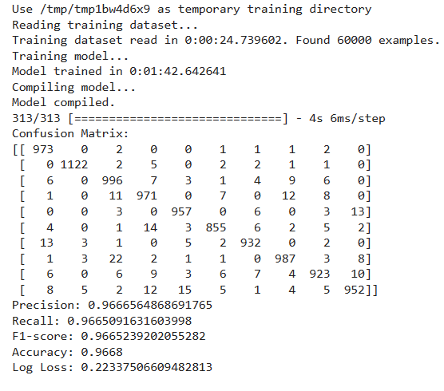

Train Accuracy Vs Depth of the Tree graph for Random Forest Classifier

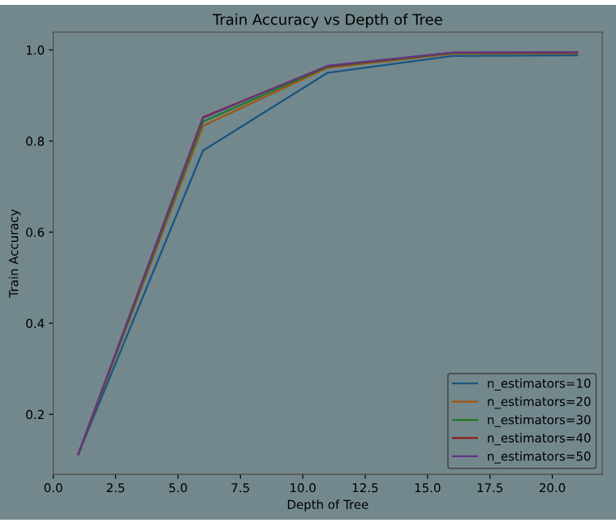

Test Accuracy Vs Depth of the Tree graph for Random Forest Classifier

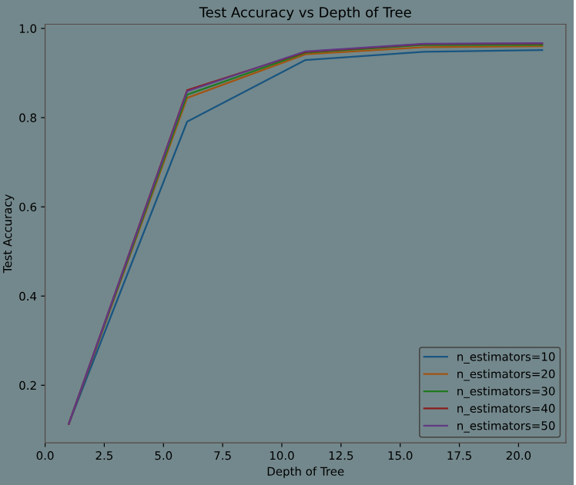

### **Q1(c)**

### **Parameter Tuning through Grid Search/Cross Validation**

Best parameters for decision tree: {‘max-depth’:15}

Best Accuracy for Decision Tree: 0.8703833333333334

### **Parameter Tuning through Random Search/Parameter Search**

Best Parameters for Decision Tree:

{'splitter': 'best', 'min_samples_split': 7, 'min_samples_leaf': 4, 'max_features': None, 'max_depth': 17, 'criterion': 'entropy'}

Best Accuracy for Decision Tree: 0.8727